

THE TECHNICAL UNIVERSITY OF KENYA

SCHOOL OF COMPUTING AND INFORMATION TECHNOLOGY

DEPARTMENT OF INFORMATION SYSTEMS AND TECHNOLOGY

**SCIT STUDENTS PROJECT PROGRESS MANAGEMENT SYSTEM (SCIT SPPMS)**

A CASE STUDY OF THE SCHOOL OF COMPUTING AND INFORMATION TECHNOLOGY AT THE TECHNICAL UNIVERSITY OF KENYA

PRESENTED BY:

**CHARLES KAIRU**

**SCII/00329/2016**

SUPERVISED BY:

MR. PETER KARIUKI

MS. NJERI NGARUIYA

A PROJECT PROPOSAL SUBMITTED TO THE SCHOOL OF COMPUTING AND INFORMATION TECHNOLOGY IN PARTIAL FULFILMENT FOR THE DEGREE OF TECHNOLOGY IN INFORMATION TECHNOLOGY PROJECT OF THE TECHNICAL UNIVERSITY OF KENYA

## CHAPTER FOUR: SYSTEM ANALYSIS AND REQUIREMENT MODELING

### Data Flow Diagrams

A data flow diagram (DFD) maps out the flow of information for any process or system. It uses defined symbols like rectangles, circles and arrows, plus short text labels, to show data inputs, outputs, storage points and the routes between each destination. Data flowcharts can range from simple, even hand-drawn process overviews, to in-depth, multi-level DFDs that dig progressively deeper into how the data is handled. They can be used to analyse an existing system or model a new one.

#### Level 0 DFD: Context Level Diagram

A context diagram gives an overview and it is the highest level in a data flow diagram, containing only one process representing the entire system.

1. All external entities are shown on the context diagram as well as major data flow to and from them.
2. The diagram does not contain any data storage.
3. The single process in the context-level diagram, representing the entire system, can be exploded to include the major processes of the system in the next level diagram. 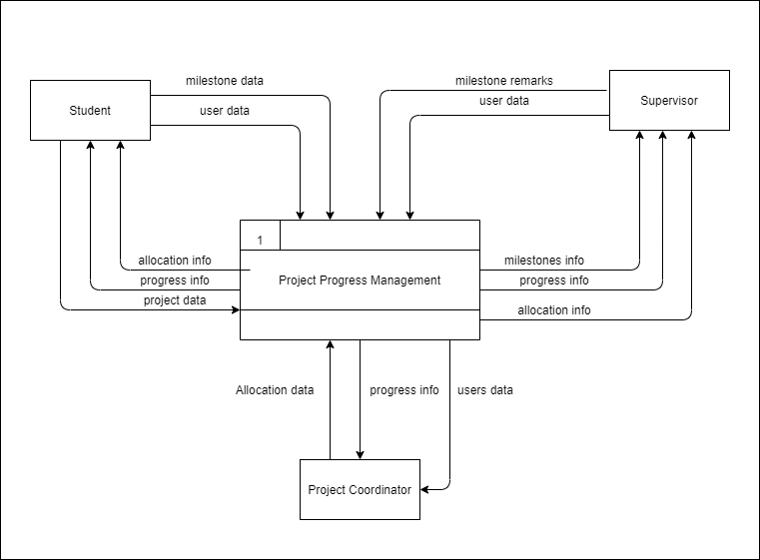

#### Level 1 DFD

The process in context diagram can be exploded further to represent details of the processing activities as shown in the level 1 DFD below.

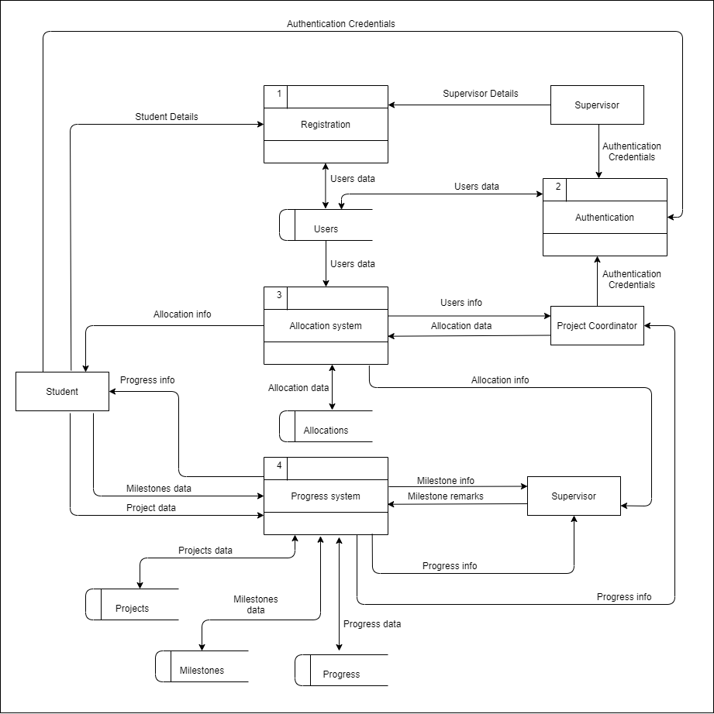

#### Level 2 DFD

This level involves extracting a particular process which has a lot of data flow linking between few external entities. The diagram below shows a level 2 DFD which extracts the progress system above into a separate diagram.

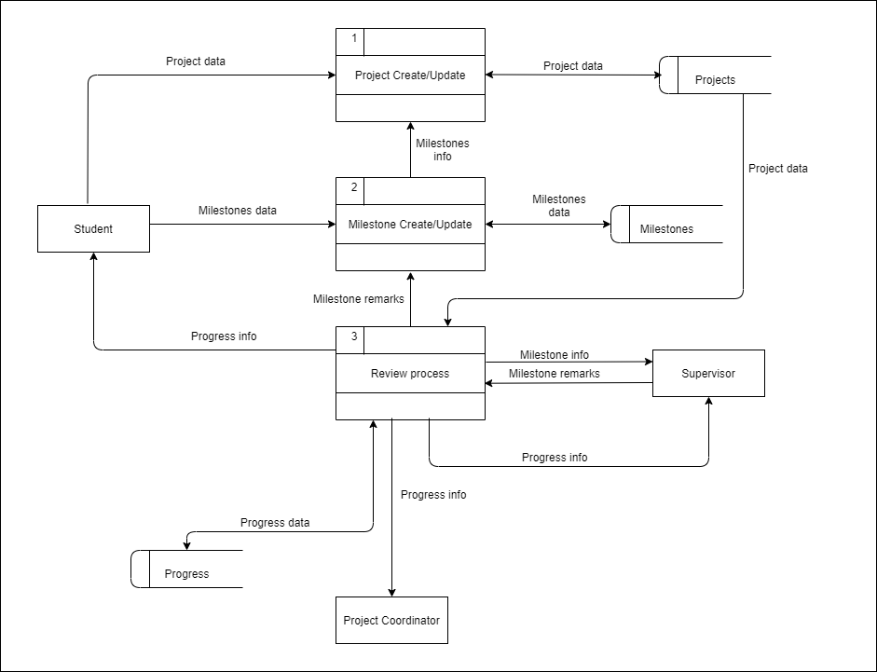

### Use Case Diagram

A use case diagram model the functionality of a system using actors and use cases. Use cases are a set of functions that the system needs to perform. A use case diagram is valuable for visualizing the functional requirements of a software that will translate into design and development priorities. They help to identify any internal or external factors that may influence the system. The following is a use case diagram of SPPMS.

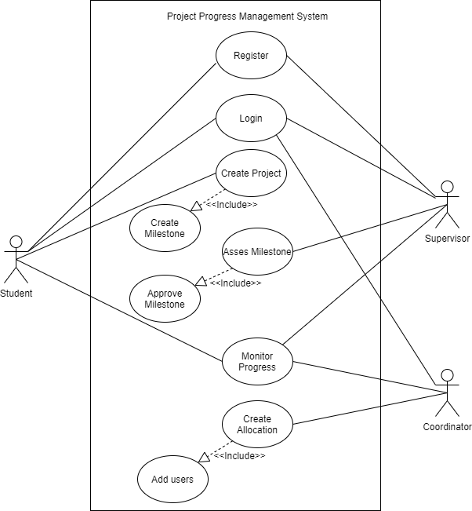

### Class Diagram

A class diagram describes the types of objects in the software system and the different types of relationships that exist among them. It shows classes, their attributes, operations (or methods), and the relationships among objects.

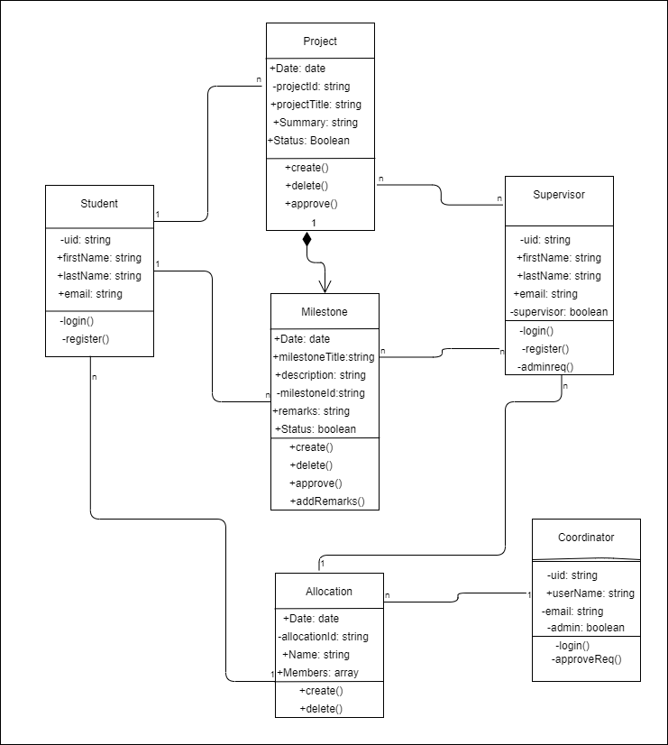

### Flowcharts

A flowchart is a graphical representation of steps. It is used for representing algorithms and programming logic. It can play an extremely important role in displaying information and assisting reasoning. It helps us visualize the complex processes of a system.

#### Sign Up and login

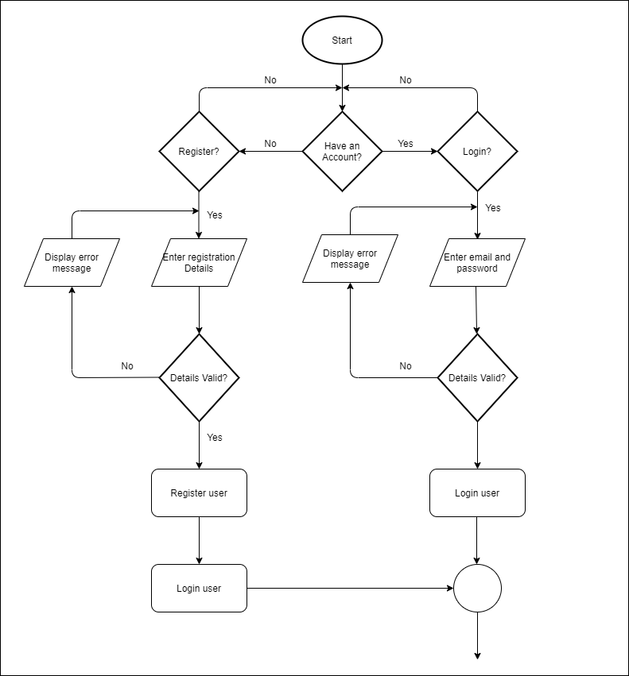

#### Student’s Flowchart

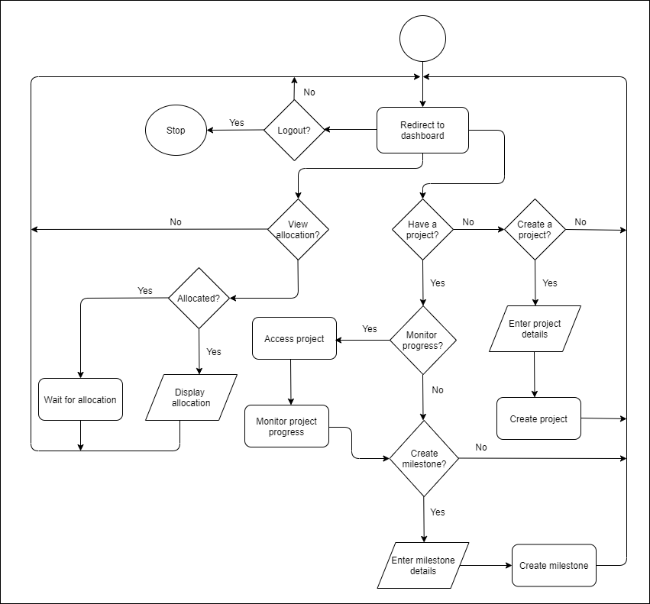

#### *Supervisor’s Flowchart*

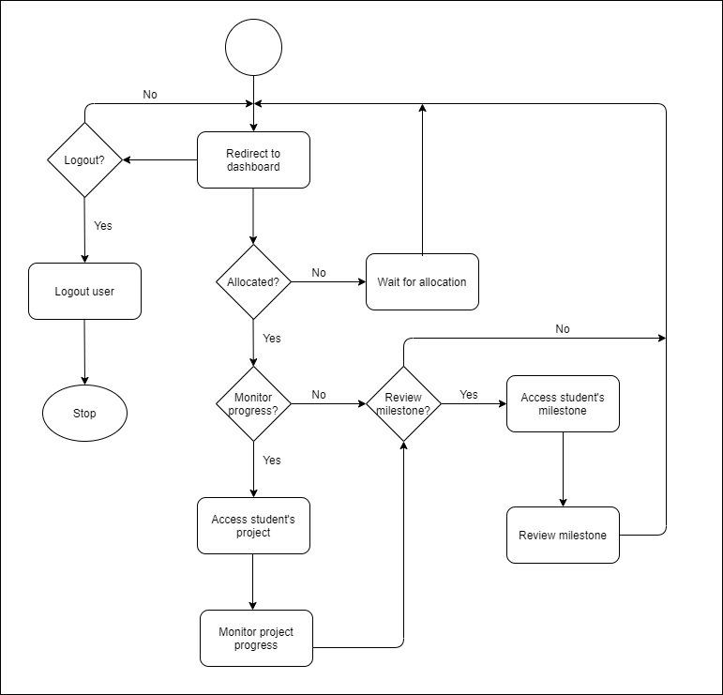

#### *Coordinator’s dashboard*

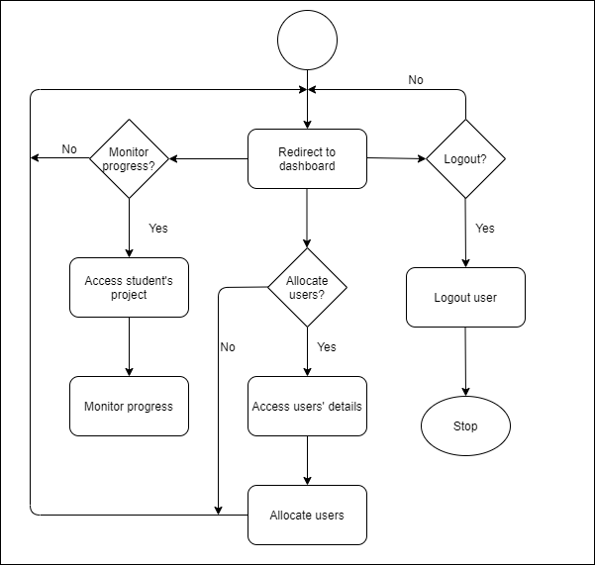

## CHAPTER FIVE: SYSTEM DESIGN

### Wireframes

A wireframe is a layout of a user interface that demonstrates what interface elements will exist on key pages. It is a critical part of the interaction design process. The aim of a wireframe is to provide a visual understanding of a page early in a project to get project team approval before the creative phase gets under way.

#### Sign Up and login

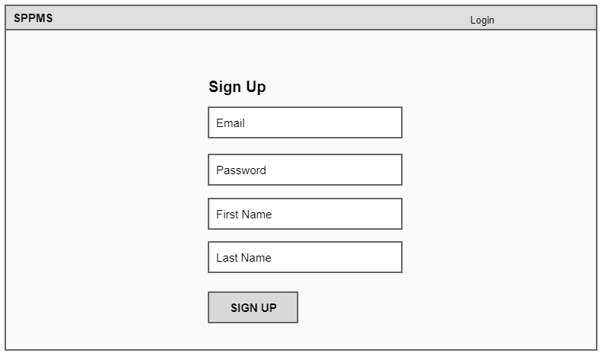

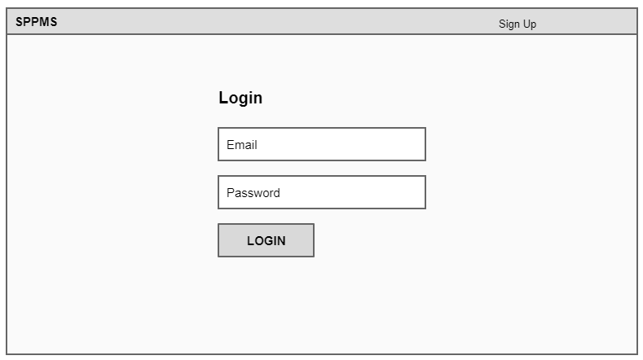

#### Student dashboard

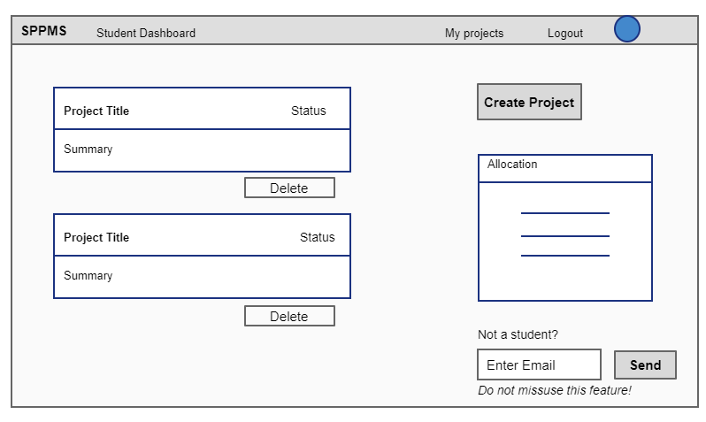

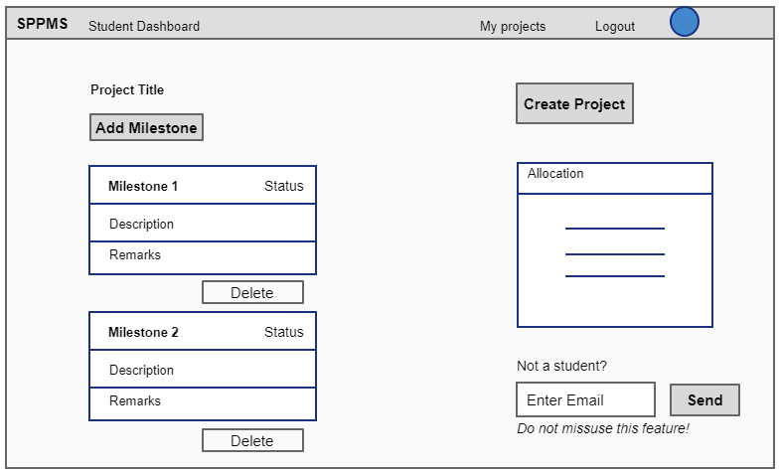

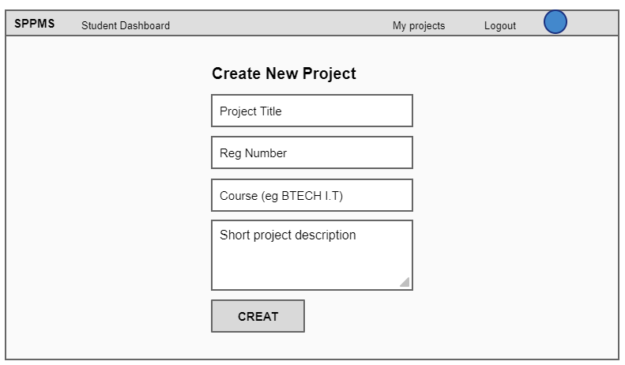

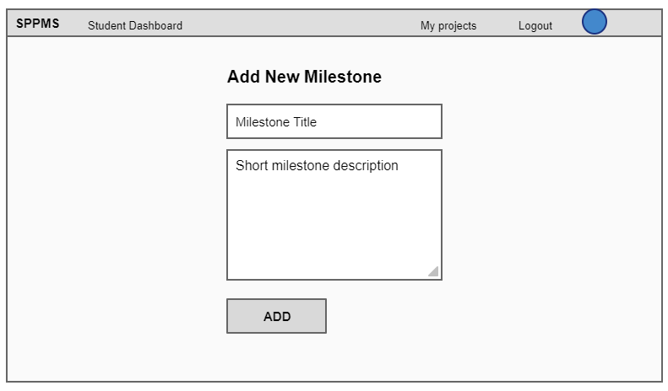

#### Supervisor dashboard

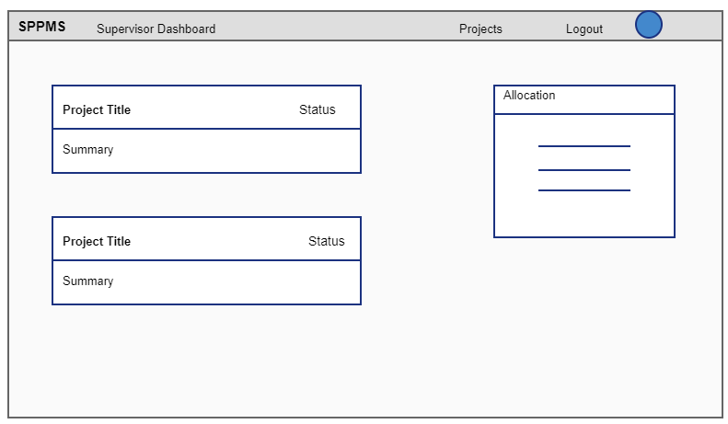

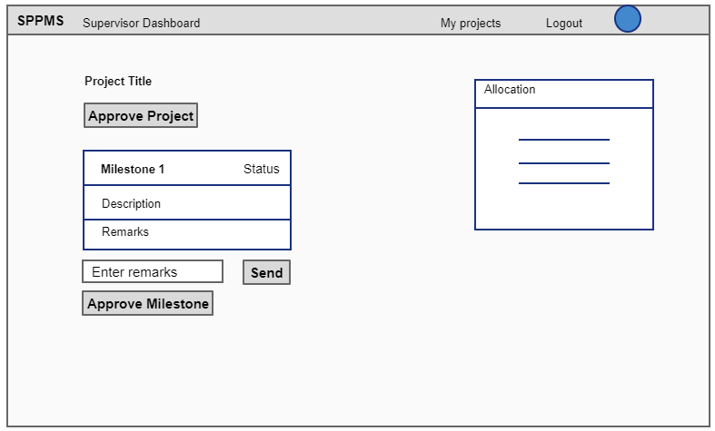

#### Project co-ordinator dashboard

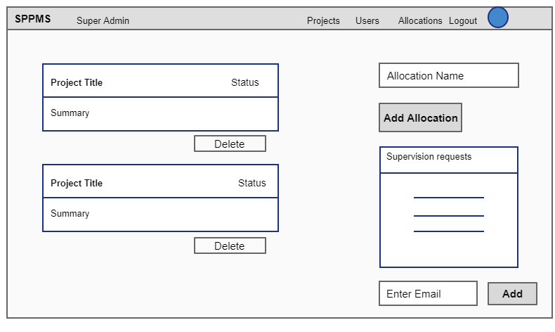

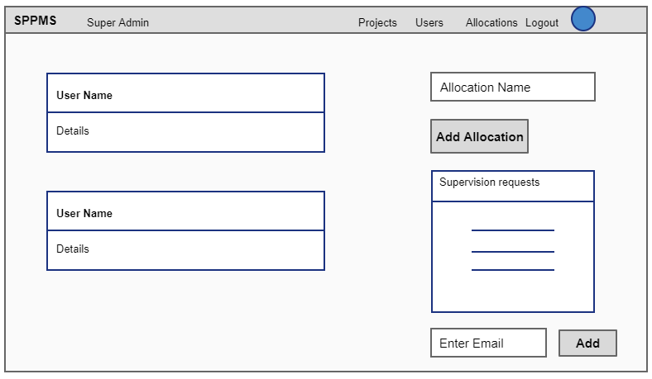

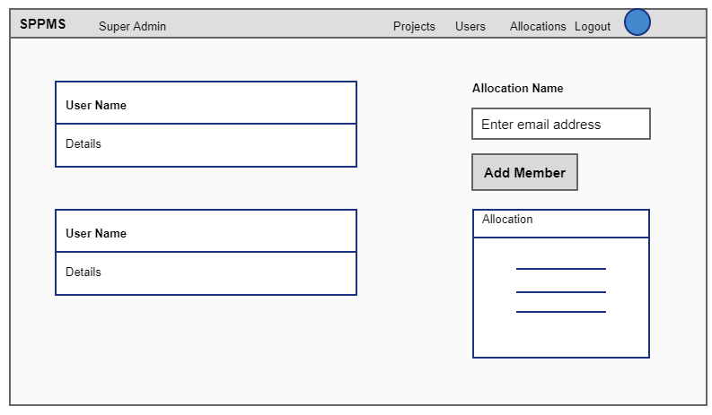

### Database schemas

#### Conceptual database design

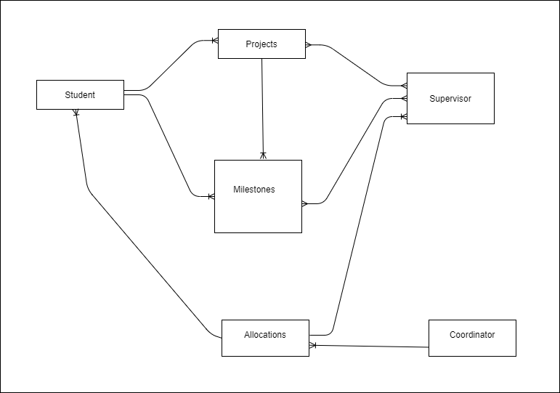

#### Logical database design

#### Physical database design

